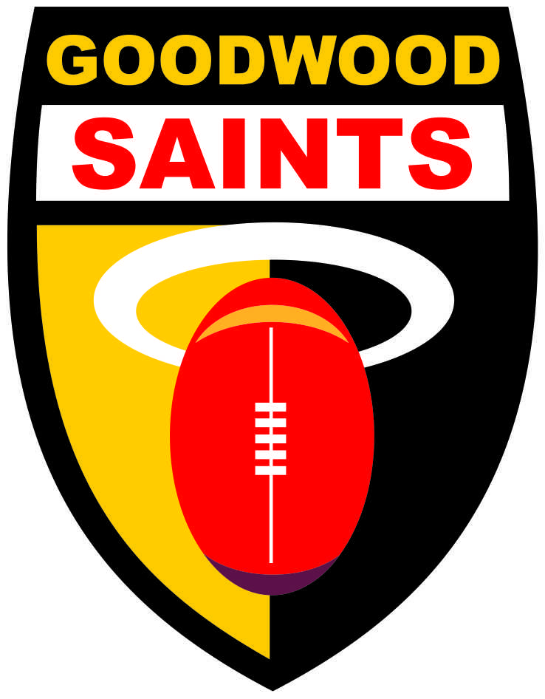

6 October 2020

Local Residents to Goodwood Oval Clubrooms

As you would be well aware, the new clubrooms at Goodwood Oval are now complete. We are very appreciative of your support and patience during the process.

As Presidents of the respective clubs that utilise the new facility we would like to let you know about a couple of upcoming events, and personally invite you to the official opening of the new clubrooms.

Event 1 – Official Opening Day, Sunday October 18, 10am until 2pm with official proceedings at 12pm.

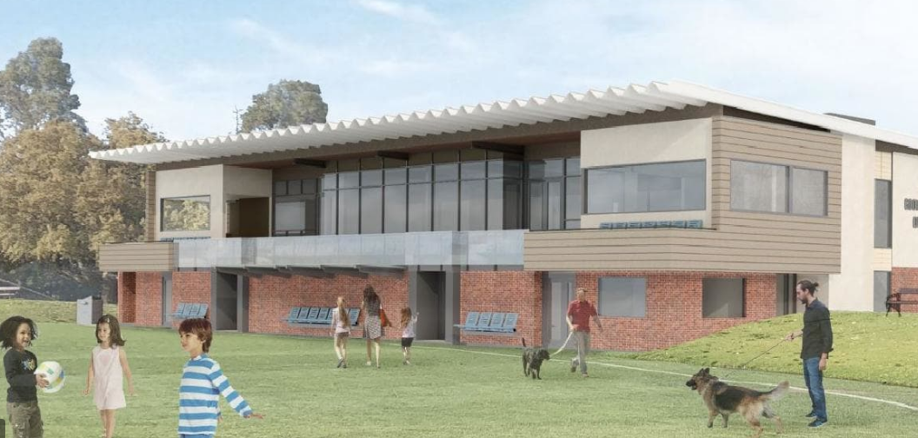

Event 2 – AFL Grand Final Day (Cricket Club only), Saturday 24th October, 7pm until midnight (members will be asked to leave the premises quietly)

Both clubs have setup pages on their websites where local residents can self-register to receive emails about upcoming club events. The same website page has the contact details of the club Presidents who you are encouraged to contact should be have issues with the club usage or wish to report any anti-social behaviour by our club members.

Cricket Club (October - March) https://goodwoodcc.com/contact/resident-updates/

Football Club (April - September) https://goodwoodsaints.com.au/resident-updates

Please go to the website pages and register yourself for local resident event emails, and we both hope to see you in person at the opening. Please come and introduce yourself!

Kind regards,

Warwick Potts Craig Scott
President President
Goodwood Cricket Club Goodwood Saints Football Club

